**Lab 3**

**Name:** Etcherla Sai Manoj **Mis. No:** 112015044 **Branch:** CSE

**Question1:**

**Code:**

#include<iostream>

using namespace std;

int getArea(int x){

return x * x;

}

int getArea(int x, int y){

return x * y;

}

double getArea(double x){

return 3.14 * x * x;

}

int main(){

int side, length, breadth;

double radius;

cout << "Enter side of square : ";

cin >> side;

cout << "Enter length and breadth of rectangle : ";

cin >> length >> breadth;

cout << "Enter radius of circle : ";

cin >> radius;

cout << "Area of square : " << getArea(side) << endl;

cout << "Area of rectangle : " << getArea(length, breadth) << endl;

cout << "Area of circle : " << getArea(radius) << endl;

return 0;

}

**Input & Output:**

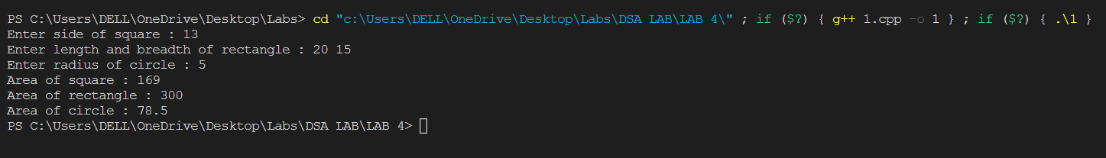

**Question2:**

**Code:**

#include<iostream>

using namespace std;

class Sample

{

float area;

public:

Sample(){

area = 0;

}

Sample(int a, int b){

cout << "Enter Lenght and breadth of rectangle : ";

cin >> a >> b;

area = a * b;

}

Sample(int a){

cout << "Enter side of square : ";

cin >> a;

area = a * a;

}

void show(){

cout << area << endl;

}

};

int main(){

int a,b,c;

Sample c1;

Sample c2(a, b);

Sample c3(c);

cout << "The area : ";

c1.show();

cout << "The area of rectangle : ";

c2.show();

cout << "The area of square : ";

c3.show();

return 0;

}

**Input & Output:**

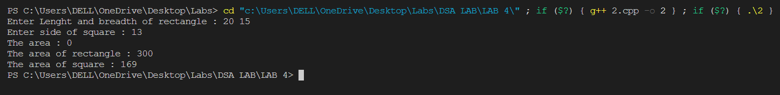

**Question3:**

**Code:**

#include<iostream>

#include<cstring>

using namespace std;

class Student{

string name;

public:

Student(){

name = "Unknown";

}

Student(string s){

cout << "Enter a name : ";

cin >> s;

name = s;

}

void show(){

cout << "Name of Student : " << name << endl;

}

};

int main(){

string a, b;

Student s1(a);

Student s2;

Student s3(b);

s1.show();

s2.show();

s3.show();

return 0;

}

**Input & Output:**

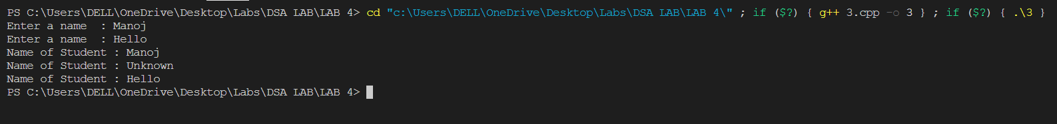

**Question4:**

**Code:**

#include<iostream>

using namespace std;

class Sample{

int *p, odd = 0, even = 0;

public:

Sample(){

p = new int[5];

cout << "Enter elements of array : ";

for(int i = 0; i < 5; i++){

cin >> p[i];

if(p[i] % 2 == 0){

even++;

}

else{

odd++;

}

}

}

void show(){

cout << "Number of even numbers : " << even << endl;

cout << "Number of odd numbers : " << odd << endl;

}

~Sample(){

delete [] p;

cout << "Destructor done";

}

};

int main(){

Sample s1;

s1.show();

return 0;

}

**Input & Output:**

